Technical Design Document
Guudo
Richard Delamore

Contents
1.0 Revision History Version 2
2.0 Development Environment 2
2.1 Game Engine 2
2.2 IDE 2
2.3 Source Control procedures 2
2.4 Third Party Libraries 2
2.5 Other Software 2
3.0 Game Overview 2
4.0 Graphics 3
5.0 Physics 3
6.0 Items Item 3
7.0 Game Flow 3
8.0 Levels 3
9.0 Interface 4
9.1 Menu 4
9.2 Camera 4
9.3 Controls 4
10.0 Asset List 4
11.0 Technical Risks 4

Revision History Version
Version | Description
1.0 | Initial Document

Development Environment

Game Engine
Unreal Engine 4.23.1

IDE
Visual Studio 2019

Source Control procedures
Gitkraken with Github (URL: https://github.com/Evildea/Omni)

Third Party Libraries

Other Software

Game Overview
Class structure (UML diagram of classes)

Guudo Game Mode
The Guudo Game Mode takes control of the scene. Besides that, the Game Mode has two primary functions:
- It handles the count-down timer and automatically moves the player to the next level when the countdown timer hits zero.
- It directly interfaces with the HUD and handles string formatting of the timer on behalf of the HUD.
Pickup Base
The Pickup Base is the base object for all pickups in the game. It has some basic functionality such as a collision sphere with a tag that indicates it is a pickup.

Guudo Character
The player possess the the Guudo Character class when the game first begins. This class is derived from the Character base class provided by Unreal.
Besides the standard character functionality Unreal provides, the Guudo character class has been extended to provide the following additional functionality:

Pickup Functionality
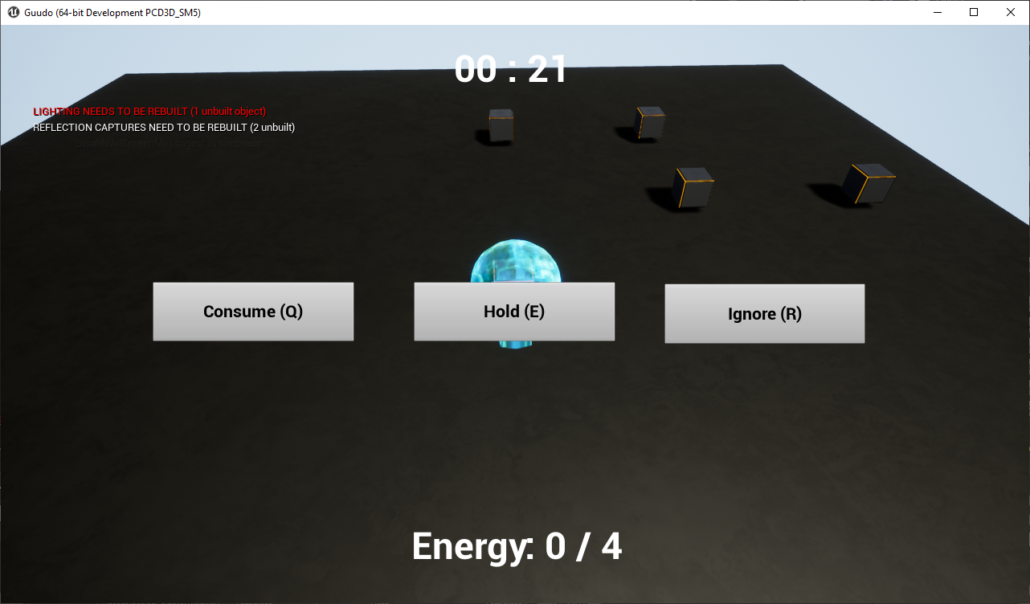
When near an object, the player can choose to pick it up by using the left-mouse button. This will present the player with an interface menu asking them to either consume the object for energy, hold it in their inventory or ignore it. The player’s character movements are then locked until they make a choice.

Consuming an Object
Consuming an object will increase the player’s energy points by 1 for a maximum of 4 points. If they already have 4 energy points, then they won’t be able to consume the object.

Holding an Object
Holding an object will place the object in the player’s inventory. These objects only become accessible again at the end of the game when they need to build their custom character. Held objects appear as small spheres they rotate around inside Guudo’s liquid head.

Ignoring an Object
Ignoring an object will neither consume it nor store it. This is effectively the same as never having picked it up in the first place.

Special Abilities
The Guudo Character has the following special abilities. Each special ability costs an energy point to use. To use these special abilities, the player needs to hit tab to cycle through them.

Shrink
Pressing MMB will shrink the Guudo Character to a smaller size. This will enable him to reach locations that would normally be impossible for him.

Grow
Pressing MMB on this ability will increase the players size allowing the player to knock over big objects allowing to access items that could normally never be reached.

High Jump
Pressing MMB on this ability will allow the player to jump higher the next time they press Spacebar to jump.

- The Guudo Character has a camera and camera arm. The distance between the camera and the model can be widened or shortened by using the mouse wheel.

Graphics

Physics

Items Item
Items that need to be collected

Game Flow

Levels

Interface

Menu

Camera

Controls

Asset List
Assets

Technical Risks

